Картинки с изображениями белорусского орнамента

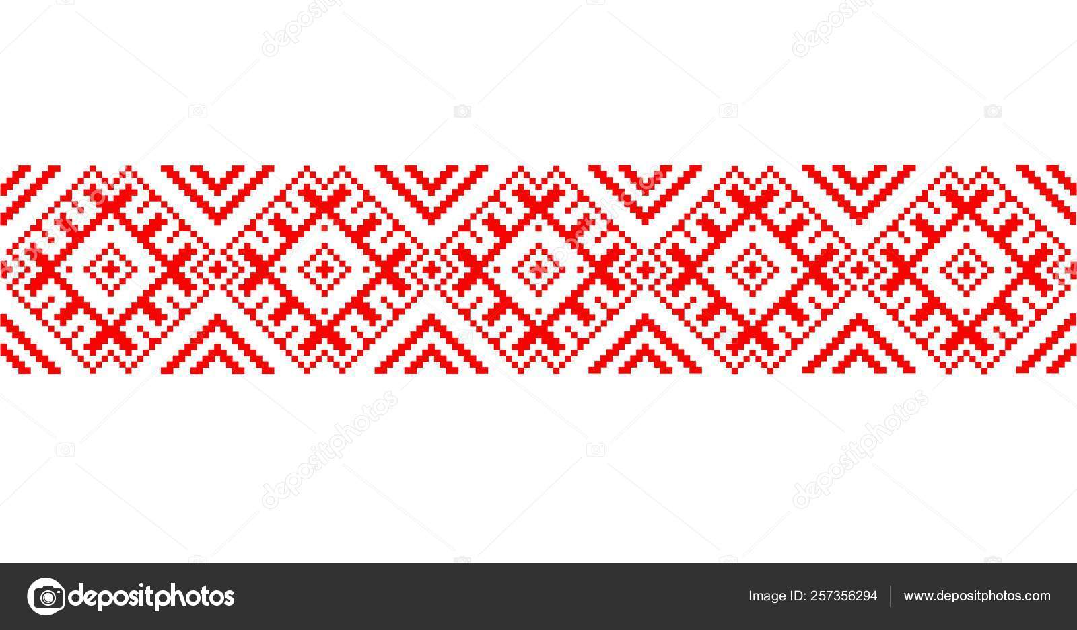

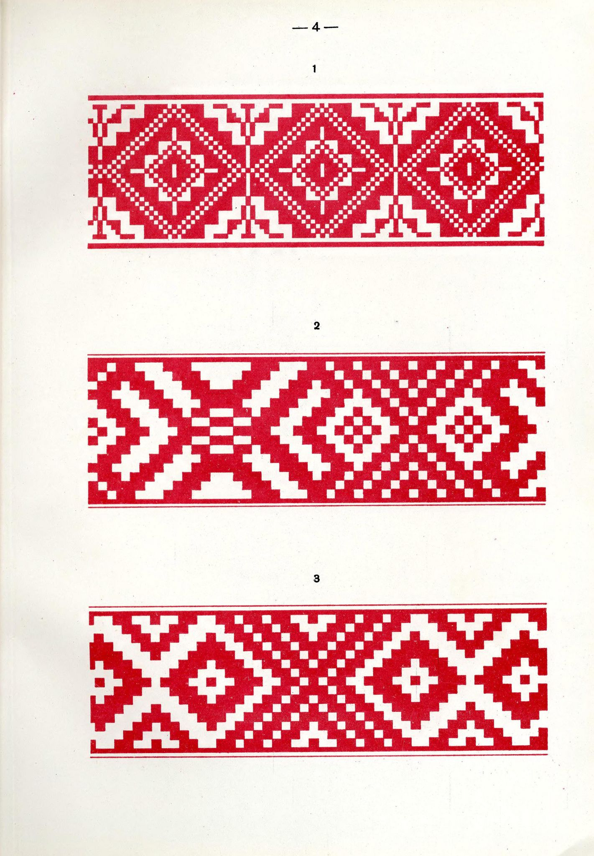

|  |  |  |  |
| --- | --- | --- | --- |
| https://www.karandash.by/image/design/10170/95.jpg | https://grizly.club/uploads/posts/2022-12/1670412439_grizly-club-p-udmurtskie-uzori-legkie-1.png | https://i.pinimg.com/originals/56/f9/98/56f998429f217c1ba614d6abad1f7ed4.jpg | https://top-fon.com/uploads/posts/2023-01/1674880964_top-fon-com-p-fon-dlya-prezentatsii-chuvashskii-ornament-162.jpg |
| Семья | Предки | Чистота | Огонь |
| https://cdn5.vectorstock.com/i/1000x1000/99/09/symbol-of-bread-vector-15149909.jpg | https://static10.tgstat.ru/channels/_0/74/74f8082585f723c458852ff1bc82332f.jpg | https://i.pinimg.com/originals/c1/ab/df/c1abdf7ca6b526336388cdb21f0abfa5.png | https://i.pinimg.com/originals/56/f9/98/56f998429f217c1ba614d6abad1f7ed4.jpg |
| Душа | Молодость | Плодовитость | Солнце |